SmartRetail360 Retail Analytics Platform
Business Insights & Executive Analytics Report
Prepared By
Milan Soni
Tools Used
PostgreSQL | SQL | Python | Power BI
Dataset
Olist Brazilian E-Commerce Dataset
1. Executive Summary
SmartRetail360 is an end-to-end retail analytics solution developed to transform raw e-commerce transaction data into actionable business intelligence. The project integrates PostgreSQL data warehousing, SQL analytics, feature engineering, customer analytics, predictive modelling, and Power BI visualization to support data-driven business decision-making.
The solution analyses more than 99,000 orders and 96,000 customers across Brazil, enabling stakeholders to monitor revenue performance, customer behaviour, seller effectiveness, product performance, and geographic trends through an interactive executive dashboard.
The primary objective of this project is to provide business leaders with a centralized analytics platform capable of identifying growth opportunities, optimizing operational performance, and improving customer satisfaction.
2. Project Architecture
Raw Olist Dataset
↓
Data Cleaning & Transformation
↓
PostgreSQL Data Warehouse
↓
Star Schema Modelling
↓
Feature Engineering
↓
Customer Analytics (RFM Segmentation)
↓
Customer Lifetime Value Analysis
↓
Churn Prediction
↓
Sales Forecasting
↓
Power BI Executive Dashboard
3. Dataset Overview
The Olist Brazilian E-Commerce Dataset contains transactional information from a large online marketplace operating across multiple Brazilian states.
Dataset Components:
• Customers Dataset
• Orders Dataset
• Order Items Dataset
• Order Payments Dataset
• Order Reviews Dataset
• Products Dataset
• Sellers Dataset
• Geolocation Dataset
Project Scale:
• 99,441 Orders
• 96,000+ Customers
• 100,000+ Transactions
• 27 Brazilian States
• Multiple Product Categories
4. Key Performance Indicators
The executive dashboard tracks the following business metrics:
Total Revenue: 20.42 million
Total Orders: 99 thousand
Average Order Value: 206.93
Average Review Score: 4.03
Total Freight Cost: 2.26 million
These KPIs provide a high-level view of business performance and customer satisfaction.
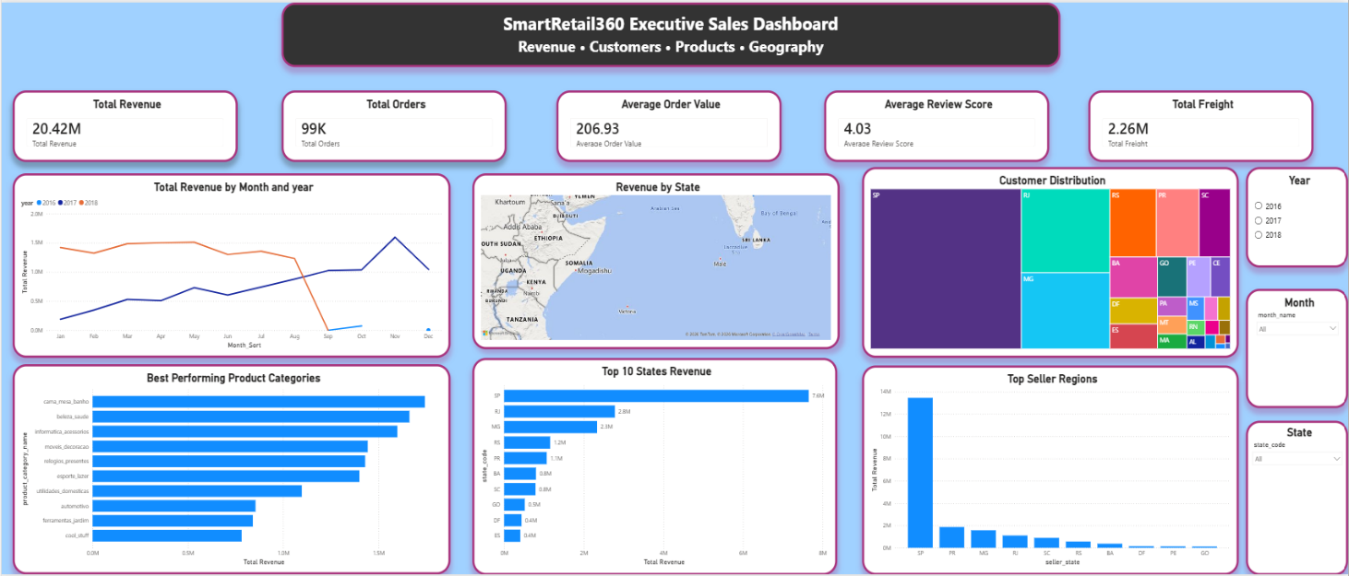
Figure 1: SmartRetail360 Executive Sales Dashboard
5. Revenue Performance Analysis
Revenue analysis indicates strong business growth throughout the observed period.
Monthly revenue trends reveal increasing customer adoption and marketplace activity between 2016 and 2018. The revenue trajectory demonstrates the successful expansion of the platform and increasing purchasing activity from customers.
Business Impact:
• Consistent revenue growth indicates a healthy business model.
• Strong sales performance supports future expansion opportunities.
• Revenue trends help management identify seasonal demand patterns.
Recommendation:
Continue investing in customer acquisition and retention programs to sustain long-term growth.
6. Geographic Revenue Analysis
Revenue generation is concentrated in a limited number of Brazilian states.
High-performing regions contribute a substantial proportion of overall revenue, indicating strong regional demand and established customer bases.
Business Impact:
• Revenue concentration creates dependency on a small number of regions.
• Lower-performing states represent untapped market opportunities.
Recommendation:
Expand marketing campaigns and logistics capabilities in emerging states to diversify revenue sources.
7. Product Category Analysis
Product category analysis reveals that a small number of categories generate the majority of sales revenue.
Several categories consistently outperform others, demonstrating strong customer demand and profitability.
Business Impact:
• High-performing categories significantly influence overall business revenue.
• Category-level insights support inventory planning and merchandising decisions.
Recommendation:
Increase inventory availability and promotional focus for top-performing product categories.
8. Customer Distribution Analysis
Customer distribution is heavily concentrated in specific regions.
The customer base demonstrates strong clustering around major population centers and economically active states.
Business Impact:
• Customer acquisition opportunities remain available in underpenetrated regions.
• Geographic concentration may create long-term growth limitations.
Recommendation:
Develop region-specific customer acquisition strategies targeting low-density markets.
9. Seller Performance Analysis
Seller performance analysis indicates that a limited number of seller regions contribute a significant share of total revenue.
Business Impact:
• Dependence on a small seller network increases operational risk.
• Strong-performing sellers represent strategic business partners.
Recommendation:
Expand the seller ecosystem and onboard additional sellers in emerging markets.
10. Customer Satisfaction Analysis
Customer review scores remain consistently positive, with an average review score exceeding 4.0.
This suggests generally strong customer satisfaction and successful order fulfilment experiences.
Business Impact:
• Positive customer experiences improve retention and repeat purchases.
• Review scores provide early indicators of operational issues.
Recommendation:
Continuously monitor low-rated products and categories to identify quality improvement opportunities.
11. Advanced Analytics Components
The SmartRetail360 platform includes several advanced analytics modules.
RFM Segmentation
Customers were segmented into:
• Champions
• Loyal Customers
• Potential Loyalists
• At Risk
• Lost Customers
This segmentation supports targeted marketing strategies.
Customer Lifetime Value (CLV)
Customers were classified into:
• VIP
• High Value
• Medium Value
• Low Value
CLV analysis enables more efficient allocation of marketing resources.
Churn Prediction
Machine learning models were developed to identify customers at risk of leaving the platform.
This enables proactive retention campaigns and customer engagement strategies.
Sales Forecasting
Time-series forecasting was implemented to estimate future revenue performance and support business planning.
12. Strategic Recommendations
Short-Term:
• Increase promotional efforts for top-performing product categories.
• Improve inventory planning processes.
• Strengthen relationships with high-performing sellers.
Medium-Term:
• Expand marketing activities in underrepresented regions.
• Improve logistics efficiency to reduce freight costs.
• Implement customer retention initiatives using churn predictions.
Long-Term:
• Diversify revenue across additional states.
• Develop advanced forecasting and recommendation systems.
• Expand business intelligence capabilities through predictive analytics.
13. Business Conclusion
SmartRetail360 successfully transformed large-scale e-commerce transaction data into actionable business intelligence through PostgreSQL data warehousing, SQL analytics, machine learning, and Power BI visualization.
The solution provides decision-makers with comprehensive visibility into revenue performance, customer behaviour, seller effectiveness, product performance, and regional trends.
By combining descriptive, diagnostic, predictive, and prescriptive analytics, SmartRetail360 demonstrates how modern data analytics can support strategic business growth and operational excellence.

